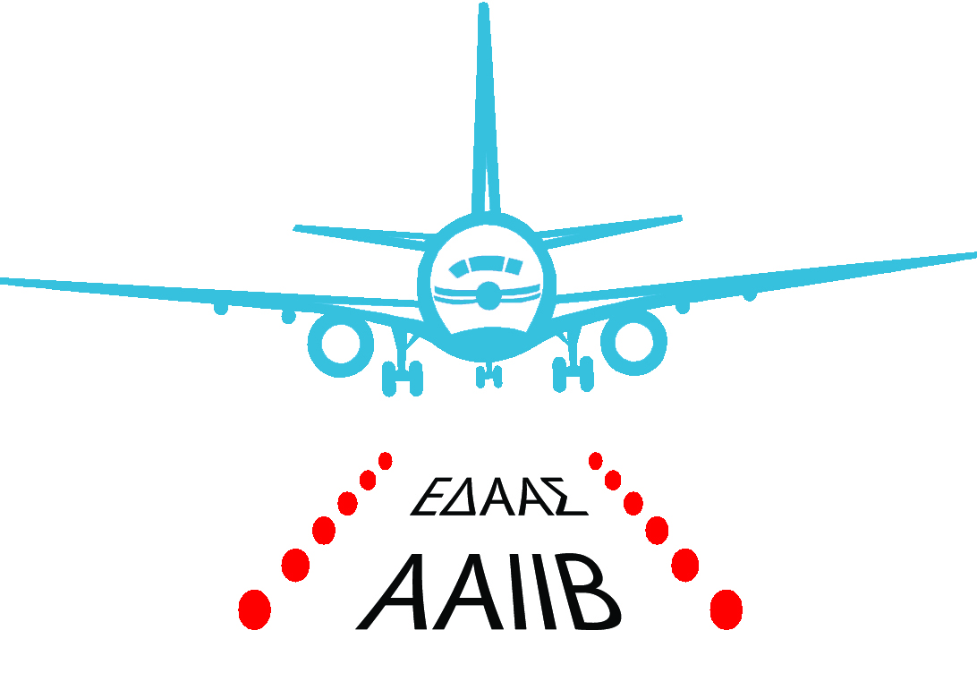
ΕΠΙΤΡΟΠΗ ΔΙΕΡΕΥΝΗΣΗΣ ΑΕΡΟΠΟΡΙΚΩΝ ΑΤΥΧΗΜΑΤΩΝ & ΣΥΜΒΑΝΤΩΝ ΚΥΠΡΟΥ
AIRCRAFT ACCIDENT AND INCIDENT INVESTIGATION BOARD OF CYPRUS

Report Form - Accident S Serious Incident

Owner, Operator P Pilot in Command I Instructor

Tick as appropriate √

REPORT FORM
In order to assist the AAIIB further in the investigation of this occurrence, please complete this Report Form to the best of your ability providing details of the event.
Please then sign it to confirm the accuracy of all details therein, and return the completed form within fourteen days to the Chief Inspector of Air Accidents at the address below.

If you have any difficulties in completing this Form or any other queries relating to the occurrence please contact the AAIIB (see contact details below).
Should additional information be required, an Inspector of Air Accidents will contact you in due course.
It is recommended that you retain a copy of your completed form for
your records
In Accordance with Annex 13 to the International Civil Aviation Organisation Convention, Regulation (EU) No 996/2010, and Cyprus Aircraft Accident & Incident Investigation Law of 2015, the sole purpose of these investigations is to prevent aviation accidents and serious incidents occurring in the future.

It is not the purpose of these investigations to apportion blame or liability.

Signature: ………………………………………..

Name: ……………………………………….. Reporting Officer

Date: ………………………………………..

Πύργος Ελέγχου Εναέριας Κυκλοφορίας 1^{ος} Όροφος. Γραφείο 214 – Διεθνής Αερολιμένας Λάρνακας Τηλ:.+357 -24643086/87, +357 24802913/915/919 T.K 43086 6650 Λάρνακα Φαξ: +357 24643052, Ιστοσελίδα: www.aaiib.gov.cy

Air Traffic Control Tower, 1st floor, 214 office – Larnaca International Airport, Tel: +357 -24643086/87 +357 -24802913/915/919
P.O BOX 43086 6650 Larnaca Fax:+357-24643052, Website: www.aaiib.gov.cy

Occurrence notification
Send to : Email address : aaiib@mcw.gov.cy
Fax : +357-24643052
- for accidents the identifying abbreviation ACCID, for serious incidents INCID; | ACCID  (Accident) |  | INCID  (Serious Incident) |  |  |  |  |  | Incident  (optional)
- manufacturer, model, nationality, flight number and registration marks, and serial number of the aircraft;
- name of owner, operator and hirer, if any, of the aircraft;
- name of the pilot-in-command, name of co-pilot for communications purpose and nationality of crew and passengers;
- date and time (local time or UTC) of the accident or serious incident; | (dd/mm/yyyy – hh:mm)  local date:  local time: |  |  |  |  | (dd/mm/yyyy – hh:mm)  UTC date:  UTC time:
- last point of departure and point of intended landing of the aircraft; | Last point of departure:  Point of intended landing:
- position of the aircraft with reference to some easily defined geographical point and latitude and longitude;
- number of crew and passengers; aboard, killed and seriously injured; others, killed and seriously injured; | Persons on board  Fatal  Serious injury  Minor |  |  | crew  crew  crew  crew |  |  |  | pax  pax  pax  pax |  |  |  | others  others  others
- description of the accident or serious incident and the extent of damage to the aircraft so far as is known;
- physical characteristics of the accident or serious incident area, as well as an indication of access difficulties or special requirements to reach the site;
- presence and description of dangerous goods on board the aircraft. | No Yes – If yes, UN#
Operation Type  (If information is available) | Commercial aviation  General aviation |  |  |  | Scheduled  Non-scheduled |  |  |  |  | Passenger  Cargo
Level of damage to aircraft  (If information is available) | Destroyed Substantial  Minor None
- identification of the originating authority
(Name – Address – Email – Phone)

